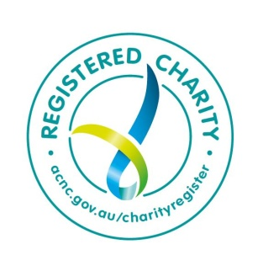
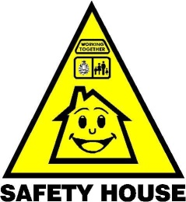
Safety House Association of Western Australia Inc. ABN 18 933 719 759
Safety House WA Inc. is a NFP Incorporated Association with ATO and ACNC accreditation as a
Registered Charity with Deductible Gift Recipient and Public Benevolent Institution status.
Safety House WA Inc. Head Office
HEAD OFFICE POSTAL ADDRESS: PO Box 340, MIDLAND DC WA 6936
VOICEMAIL: (08) 6142 8579 EMAIL: safety@safetyhousewa.org.au
WEBSITE: www.safetyhousewa.org.au

FREE CONTACT NUMBER CARD FOR SCHOOL BAGS
It can be vitally important to have emergency contact details available in your child’s school bag. This will ensure that if a child needs help from a Safety House or another trusted adult that person can easily get in contact with the child’s parents or carers.
Safety House has created an emergency contact number plastic card that a child could have securely kept inside their school bag. Then; no matter how upset the child might be; the Safety House person or trusted adult can easily find the right contact number to help the child.
The Safety House Contact Number Cards are very similar in size to a standard credit card, made out of hard plastic and printed with the child’s basic contact information details. For personal safety reasons there is no address or family surname on the card, just sufficient information that will help the Safety House person or trusted adult contact the right person and school as quickly as possible if the child is in need of help. The Contact Number Card is available exclusively from Safety House WA Inc. for any Primary School family to order. The card can then be kept safely in the child’s school bag just in case they ever need to give out a contact number when they are hurt or upset.

HOW TO ORDER A SAFETY HOUSE WA CONTACT NUMBER CARD
Safety House WA Inc. Head Office makes the Contact Number Card available to School Parents and any other local families ABSOLUTELY FREE OF CHARGE.
To order your FREE Contact Number Card; that will be a similar design to the image shown below; please email the Safety House WA Head Office safety@safetyhousewa.org.au the details of each child’s first name and a MAXIMUM of 2 contact names and numbers. You can order contact number cards for as many of your children as you wish. When your order is received, the Contact Cards will be printed and delivered to your Primary School Office, where parents will be advised by the school and the cards can be picked up.

Jo-Anne
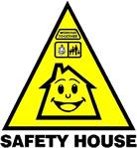
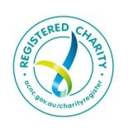
MY IMPORTANT CONTACT NUMBERS
Mum (Sue) 0412 345 678
Grandpa (Bob) 9765 5432
IMAVILLE PRIMARY SCHOOL 9123 4567
Feeling Unsure? Knock on a Safety House Door!

PLEASE NOTE THIS IMAGE IS OVERSIZE, THE ACTUAL SIZE IS ABOUT THE SAME AS A CREDIT CARD

